**Light – Reflection and Refraction**

# Reflection of Light

* Reflection is the phenomenon of bouncing back of light into the same medium on striking the surface of any object.

## Laws of Reflection

* + First law: The incident ray, the normal to the surface at the point of incidence and the reflected ray, all lie in the same plane.
  + Second law: The angle of reflection (r) is always equal to the angle of incidence(i).

ir

* The image formed by a **plane mirror** is always
  + virtual and erect
  + of the same size as the object
  + as far behind the mirror as the object is in front of it
  + laterally inverted
* **Spherical mirrors** are of two types:



**Spherical Mirrors**

**Convex mirror or diverging mirrors**

**Concave mirror orconverging**

**mirrors**

* + **Convex mirrors or diverging mirrors** in which the reflecting surface is curved outwards.
  + **Concave mirrors or converging mirrors** in which the reflecting surface is curved nwards.
* Some terms related to spherical mirrors:
  + The **centre of curvature (C)** of a spherical mirror is the center of the hollow sphere of glass, of which the spherical mirror is apart.
  + The **radius of curvature (R)** of a spherical mirror is the radius of the hollow sphere of glass, of which the spherical mirror is apart.
  + The **pole (P)** of a spherical mirror is the centre of themirror.
  + The **principal axis** of a spherical mirror is a straight line passing through the centre of curvature C and pole P of the sphericalmirror.
  + The **principal focus (F) of a concave mirror** is a point on the principal axis at which the rays of light incident on the mirror, in a direction parallel to the principal axis, actually meet after reflection from themirror.
  + The **principal focus (F) of a convex mirror** is a point on the principal axis from which the rays of light incident on the mirror, in a direction parallel to the principal axis, appear to diverge after reflection from themirror.
  + The **focal length (f)** of a mirror is the distance between its pole (P) and principal focus(F).
  + For spherical mirrors of small aperture, **R =2f**.

## Sign Conventions for Spherical Mirrors

According to **New Cartesian Sign Conventions**,

* + All distances are measured from the pole of the mirror.
  + The distances measured in the direction of incidence of light are taken as positive and *vice versa*.
  + The heights above the principal axis are taken as positive and *vice versa*.

## Rules for tracing images formed by spherical mirrors

**Rule 1:** A ray which is parallel to the principal axis after reflection passes through the principal focus in case of a concave mirror or appears to diverge from the principal focus in case of a convex mirror.

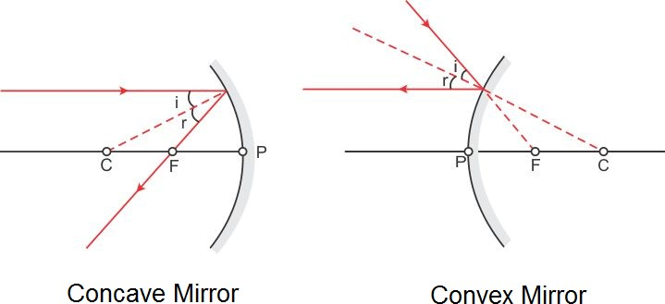

**Rule 2:** A ray passing through the principal focus of a concave mirror or a ray which is directed towards the principal focus of a convex mirror emerges parallel to the principal axis afterreflection.

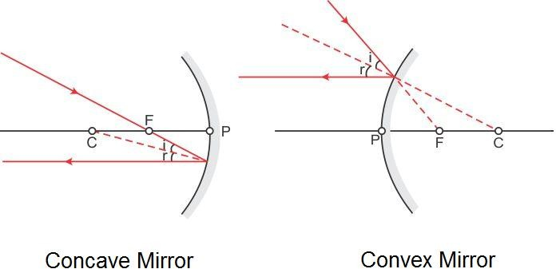

**Rule 3:** A ray passing through the centre of curvature of a concave mirror or directed towards the centre of curvature of a convex mirror is reflected back along the same path.

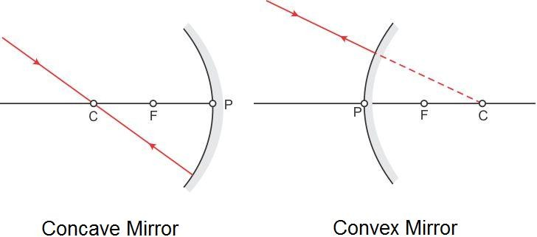

**Rule 4:** A ray incident obliquely towards the pole of a concave mirror or a convex mirror is reflected obliquely as per the laws of reflection.

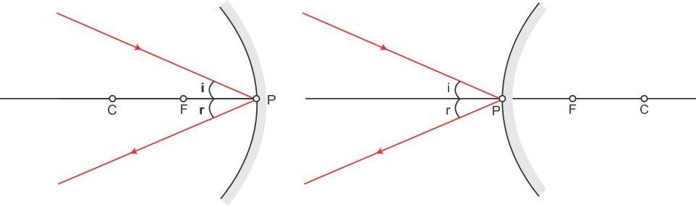

* **Image formation by a concavemirror**

## RayDiagrams

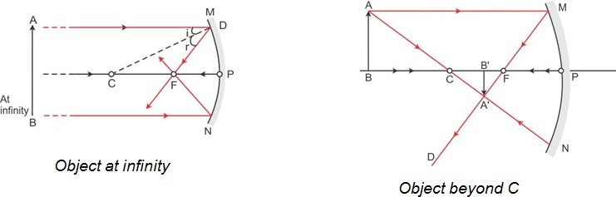

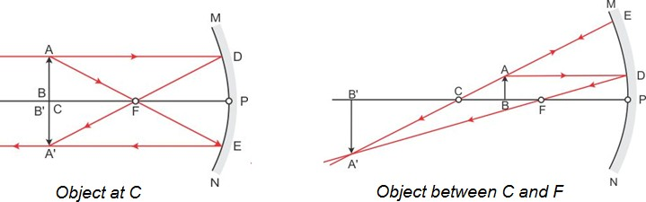

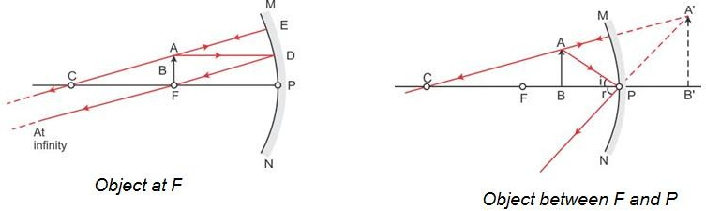

* + **Characteristics of imagesformed**

|  |  |  |  |
| --- | --- | --- | --- |
| **Position of**  **object** | **Position of**  **image** | **Size of image** | **Nature of image** |
| At infinity | At focus F | Highly diminished | Real and inverted |
| Beyond C | Between F and C | Diminished | Real and inverted |
| At C | At C | Equal to size of object | Real and inverted |
| Between C and F | Beyond C | Enlarged | Real and inverted |
| At F | At infinity | Highly enlarged | Real and inverted |
| Between F and P | Behind the mirror | Enlarged | Virtual and erect |

* **Image formation by a convexmirror**
* **RayDiagrams**

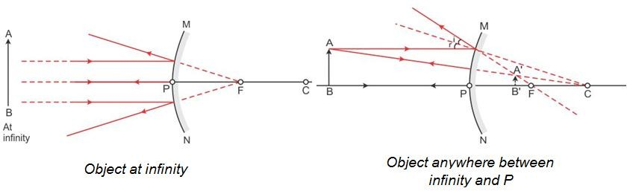

* **Characteristics of imagesformed**

|  |  |  |  |
| --- | --- | --- | --- |
| **Position of object** | **Position of**  **image** | **Size of image** | **Nature of**  **image** |
| At infinity | At focus F behind  the mirror | Highly diminished,  point sized | Virtual and erect |
| Anywhere between infinity and the pole  of the mirror | Between P and F behind the mirror | Diminished | Virtual and erect |

* **MirrorFormula**

The object distance (u), image distance (v) and focal length (f) of a spherical mirror are related as

$$\frac{1}{f} = \frac{1}{u} + \frac{1}{v}$$

* **Linear Magnification (m)** produced by a spherical mirroris

**m size of image (h2 )  image distance (v) size ofobject(h1) object distance(u)**

m is **negative** for real images and **positive** for virtual images.

# Refraction of Light

* The phenomenon of change in the path of a beam of light as it passes from one medium to another is called refraction oflight.
* The **cause of refraction** is the change in the speed of light as it goes from one medium toanother.

## Laws ofRefraction

* + FirstLaw:Theincidentray,therefractedrayandthenormaltotheinterfaceoftwomediaat the point of incidence, all lie in the sameplane.
  + Second Law: The ratio of the sine of the angle of incidence to the sine of the angle of refraction is constant for a given pair ofmedia.

sinisinr

constant 1n

This law is also known as **Snell’s law**.

2

The constant, writtenas1n is called the **refractive index** of the secondmedium (in which the

2

refracted ray lies) with respect to the first medium (in which the incident ray lies).

* **Absolute refractive index (n)** of a medium is givenas

**n** **speed of lightinvacuum c**

**speed of light inthemedium v**

* When a beam of light passes from medium 1 to medium 2, the refractive index of medium 2 with respect to medium 1 is called the **relative refractive index**, represented by 1n ,where

2

**1n n2 ** **v1**

**cv2**

**cv1**

**2**

**n1 v2**

Similarly, the refractive index of medium 1 with respect to medium 2 is

**2n n1 ** **v2**

**cv1**

**cv2**

**1**

**n2 v1**

**** **1n 2 n 1**

**2 1**

**or,**

**1n 1**

**2 2**

**n**

**1**

* While going from **a rarer to a denser medium**, the ray of **light bends towards the normal**. While going from **a denser to a rarer medium**, the ray of **light bends away from thenormal.**

## Conditions for norefraction

* + When light is incident normally on aboundary.
  + When the refractive indices of the two media areequal.
* In the case of a **rectangular glass slab**, a ray of light suffers **two refractions**, one at the air–glass interface and the other at the glass–air interface. The emergent ray is **parallel** to the direction of the incidentray.



**SphericalLens**

**Convex lens or diverging lens**

**Concave lens or converging lens**

* **Convex lens or converging lens** which is thick at the centre and thin at theedges.
* **Concave lens or diverging lens** which is thin at the centre and thick at theedges.
* Some terms related to sphericallenses:
  + The central point of the lens is known as its **optical centre(O)**.
  + Each of the two spherical surfaces of a lens forms a part of a sphere. The centres of these spheres are called **centres of curvature** of the lens. These are represented as **C1**and**C2**.
  + The **principal axis** of a lens is a straight line passing through its two centres ofcurvature.
  + The **principal focus of a convex lens** is a point on its principal axis to which light rays parallel to the principal axis converge after passing through thelens.
  + The **principal focus of a concave lens** is a point on its principal axis from which light rays, originally parallel to the principal axis appear to diverge after passing through thelens.
  + The **focal length (f)** of a lens is the distance of the principal focus from the opticalcentre.

## Sign Conventions for SphericalLenses

According to **New Cartesian Sign Conventions**,

* + All distances are measured from the optical centre of thelens.
  + The distances measured in the direction of incidence of light are taken as positive and *viceversa*.
  + The heights above the principal axis are taken as positive and *viceversa*.

## Rules for tracing images formed by sphericallens

**Rule 1:** A ray which is parallel to the principal axis, after refraction passes through the principal focus on the other side of the lens in case of a convex lens or appears to diverge from the principal focus on the same side of the lens in case of a concave lens.

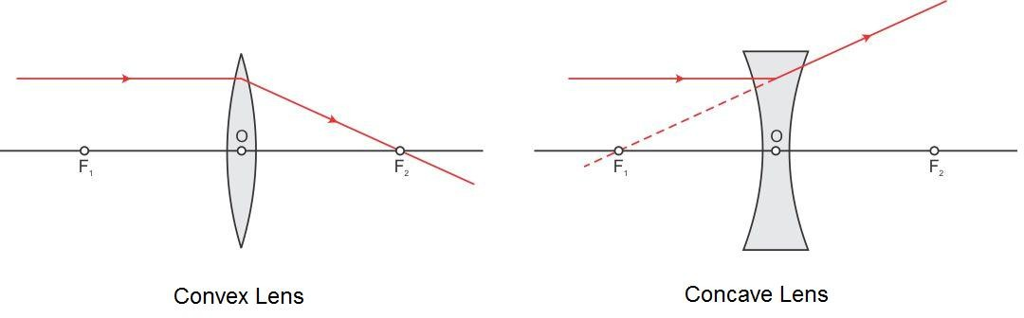

**Rule 2:** A ray passing through the principal focus of a convex lens or appearing to meet at the principal focus of a concave lens after refraction emerges parallel to the principalaxis.

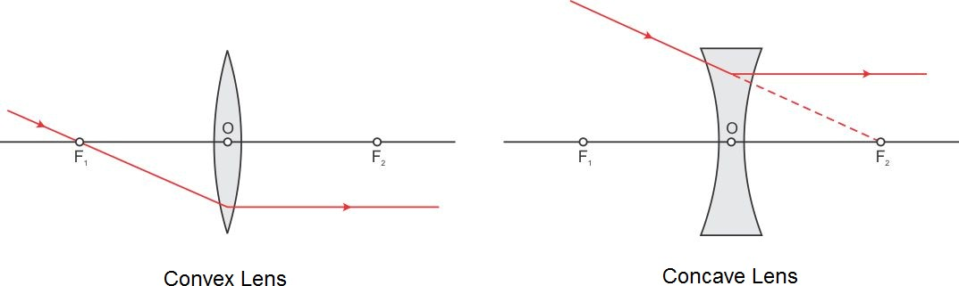

**Rule 3:** A ray passing through the optical centreof a convex lens or a concave lens emerges without any deviation.

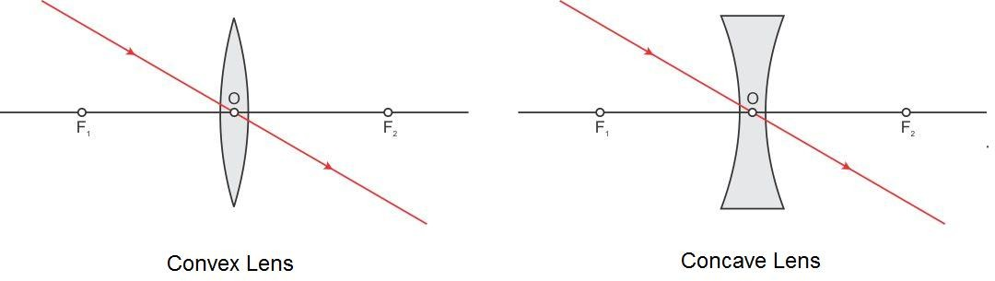

* **Image formation by a convexlens**

## RayDiagrams

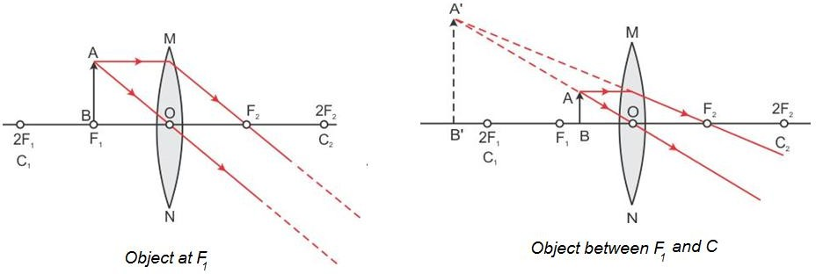

* + **Characteristics of imagesformed**

|  |  |  |  |
| --- | --- | --- | --- |
| **Position of object** | **Position of**  **image** | **Size of image** | **Nature of image** |
| At infinity | At focus F2 | Highly diminished | Real and inverted |
| Beyond 2F1 | Between F2 and  2F2 | Diminished | Real and inverted |
| At 2F1 | At 2F2 | Equal to size of  object | Real and inverted |
| Between F1 and  2F1 | Beyond 2F2 | Enlarged | Real and inverted |
| At focus F1 | At infinity | Highly enlarged | Real and inverted |
| Between F1 and O | Beyond F1 on the  same side as the object | Enlarged | Virtual and erect |

* **Image formation by a concavelens**
* **RayDiagrams**

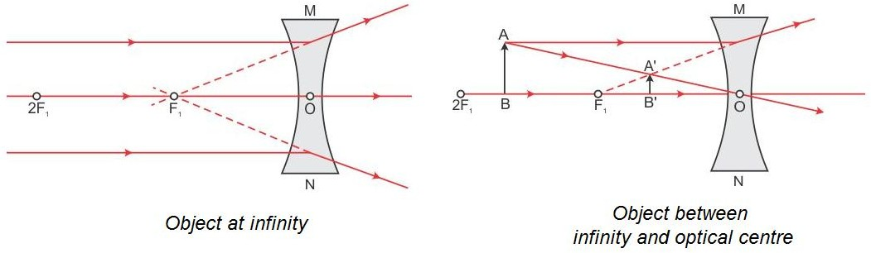

* **Characteristics of imagesformed**

|  |  |  |  |
| --- | --- | --- | --- |
| **Position of**  **object** | **Position of image** | **Size of image** | **Nature of image** |
| At infinity | At focus F1 | Highly diminished | Virtual and erect |
| Between infinity  and O | Between focus F1  and O | Diminished | Virtual and erect |

* **LensFormula**

Object distance (u), image distance (v) and focal length (f) of a spherical lens are related as

1 1 = 1

1. u f

* **Linear Magnification (m)** produced by a spherical lensis

msizeofimage(h2)imagedistance(v) size of object(h1) object distance(u)

m is **negative** for real images and **positive** for virtual images.

## Power of alens

* + Power of a lens is the reciprocal of the focal length of the lens. Its S.I. unit is **dioptre(D)**.

**P (dioptre) **

**1**

**f metre**

* + Power of a **convex lens** is **positive** and that of a **concave lens** is**negative**.
  + When several thin lenses are placed in contact with one another, the **power of the combination of lenses** is equal to the algebraic sum of the powers of the individuallenses.

**P P1 P2 P3 P4 ...**